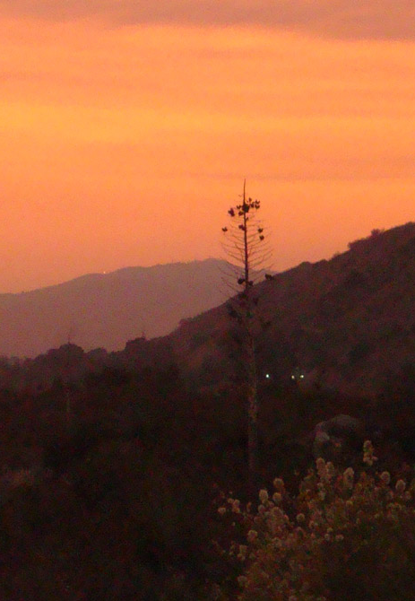


What I Love in Sunland

© 2010 by Maja Trochimczyk

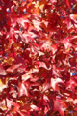
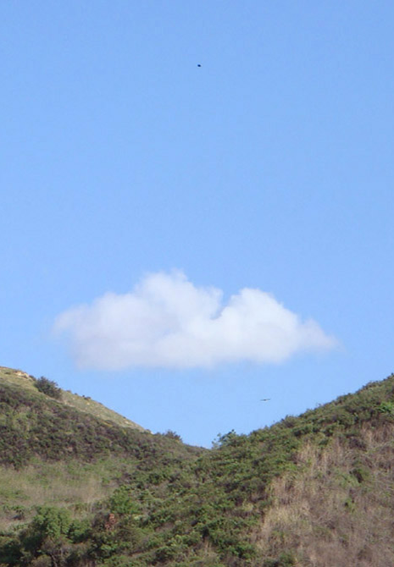
1.
The strong arms of the mountains,
embracing, protecting our town

2.
Lights scattered in the night valley
during my drive to the safety of home
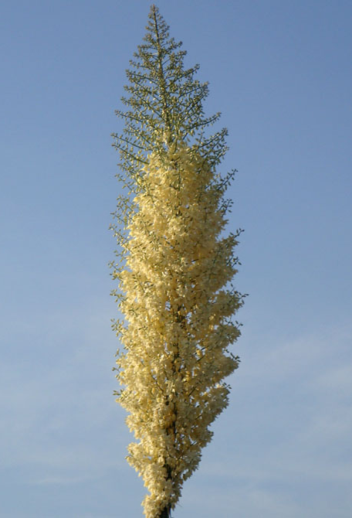
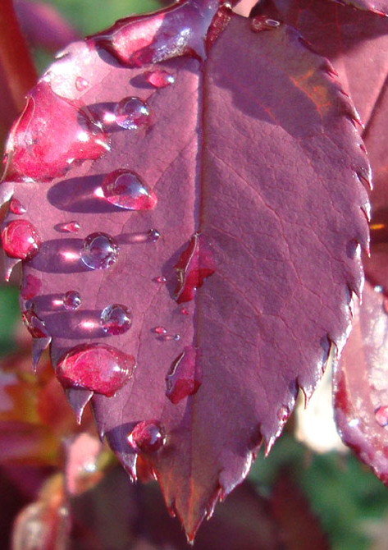
3.
How clouds sit on the hilltops
squishing them with their fat bottoms

4.
River playing hide-and-go-seek under the bridge
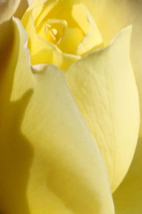
to nowhere: “now you see me – now you don’t”

5.
Towering white glory of yucca flowers in June –
we are Lilliputians in giants’ country

6.
The mockingbird’s melodies floating above
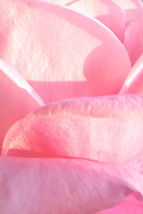
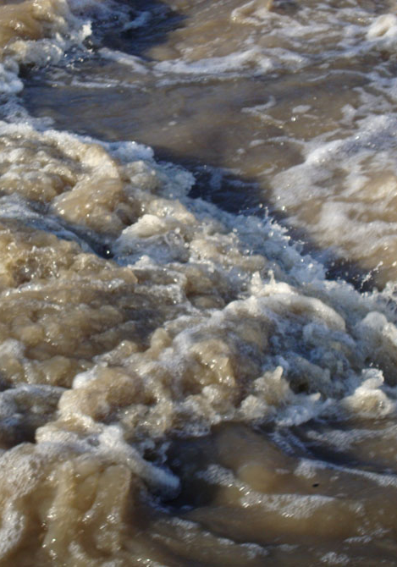
red-roofed houses asleep on sunny streets

7.
Armenian fruit tarts sweeter than fresh grapefruit
and pomegranate from my trees

8.
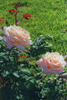
Hot, shimmering air, scented with sage and jasmine,

carved by the hummingbird’s wings

9.
The rainbow of roses, always blooming
in my secret garden

www.trochimczyk.net

