CHOPIN WITH CHERRIES: A TRIBUTE IN VERSE, edited by Maja Trochimczyk. Los Angeles: Moonrise Press, 2010. Available from www.lulu.com and soon from Amazon, etc. ISBN 978-0-9819693-0-5. www.moonrisepress.com/chopin.html
Paperback Edition - $23.00 PDF Download - $8.00

Chopin with Cherries II: Poetry and Music at the Ruskin, Saturday, May 8, 2010, 7 p.m. Ruskin Art Club, 800 S. Plymouth, Los Angeles, CA 90005

The pianist NEIL GALANTER began his musical studies at the age of seven. He gave his first recital at the age of nine, and made his debut at twelve with orchestra. He has since gone on to play many recitals, concerts as soloist, chamber musician and with orchestra throughout the USA, Mexico, Canada, Europe, Australia and New Zealand including appearances at Centenary Hall in Leeds, Salle Cortot in Paris, McCain Hall in Dublin, Ulster Hall in Belfast, the Sydney Opera House, Weill Recital Hall in New York, and the Concertgebouw in Amsterdam. He is a researcher and exponent of many major Spanish, English, French and Belgian composers: Xavier Montsalvatge, the well known Catalan composer, with whom Galanter was good friends, lauded Mr. Galanter’s interpretations of Spanish Music and invited Mr. Galanter many times to Spain for concerts and performances of his works. William Blezard of the UK wrote a piano work especially for Mr. Galanter during his 2002 Australian Tour. Recently, he has collaborated in a series of chamber music and solo concerts with members of the LA Philharmonic, including several performances of the TURINA Piano Quartet. In 2008, he gave the American Premiere of the Belgian Composer Marcel Poot’s Piano Concerto. Last summer saw the EP Release of his CD album Catalan Piano Music on iTunes, Amazon and other major music outlets. In honor of the Chopin bicentennial this year, there will be a re-release of a Chopin CD and he is also producing a hip/hop music and dance program combining a wide variety of genres and styles which will premiere late this year. He is very interested in bridging the gaps between many genres of music and enjoys working in crossover genres of music in many different musical communities. In May of last year, he made his debut as the Musical Director for the first anniversary gala of the 88’s Cabaret Series at the Republic in West Hollywood playing rock and pop music. Most recently, he has been working with the Spanish and Flamenco Dancer Inesita in a new program of Spanish Music celebrating the Dance & Music of Spain which will be touring Southern California in the coming months. He records for Disques Pyrennes Records. Some of his CDs are on sale this evening at this performance. Visit pianist NEIL GALANTER’s websites:
www.neilgalanter.com www.myspace.com/neilgalanterpianist
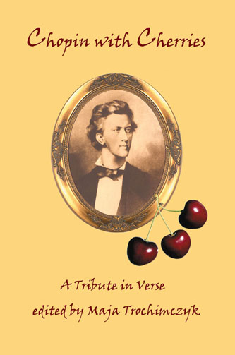
Chopin with Cherries I:
An Evening of Music and Poetry

Sunday, April 11, 2010, 6 p.m.
Featuring a new Chopin Tapestry by Monique Lehman

South Pasadena Library Auditorium, 1115 El Centro Street,
South Pasadena, CA 91030. Free Admission.
PROGRAM
PART 1 – FEATURING CONCERT ARTIST
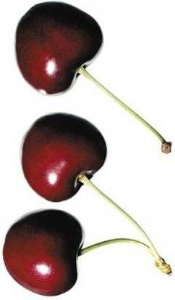
DR. NEIL GALANTER

Polonaise in C-sharp Minor, Op. 26, No. 1
John Z. Guzlowski
Millicent Borges Accardi
Kath Abela Wilson

Mazurka in A minor, Op. 17, No. 4
Amy Lowell
Maja Trochimczyk
Erika Wilk

Mazurka in C Major, Op. 24, No. 1
Linda Nemec Foster
Rick Lupert
Elizabyth Hiscox

Nocturne in F-sharp Major, Op 15, No. 2
Lia Brooks
Lola Haskins
Marlene Hitt

Prelude in D-flat Major, Op. 28, No. 15 (“Raindrop”)
Laura Mays Hoopes
Niels Petersen
Susan Rogers

Impromptu in F-sharp Major, Op. 36

INTERMISSION
The official unveiling of a new CHOPIN TAPESTRY

By MONIQUE LEHMAN, prior to its exhibition in Poland
PART 2 – FEATURING STUDENTS OF PROF. ROZA YODER,
AZUSA PACIFIC UNIVERSITY
KRISTI CHIOU – Etude in G-Flat Major, Op. 10, No. 5, "Black Key"
Elizabeth Murawski
Radomir Luza
Helen Graziano

KRISTI CHIOU – Nocturne in A-flat Major, Op 32, No. 2
Victor Contoski
Peggy Castro
Russell Salamon

STACI CHIOU – Nocturne in F Major, Op. 15, No. 1
Kathi Stafford
Martin WiIllitts, Jr.
Marilyn N. Robertson
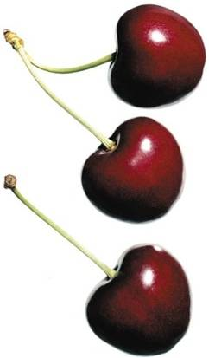
SUE ZHOU – Polonaise Fantasie in A-flat Major, Op. 61
Roxanne Hoffman
Mira N. Mataric
Ruth Nolan

SUE ZHOU – Waltz in F Minor, Op. 70, No. 2
Dean Pasch
Lois P. Jones
Emily Fragos

ANNA NIZHEGORODTSEVA – Ballade No. 4 in F Minor, Op. 52

Note: “This activity is not sponsored by the City of South Pasadena or the South Pasadena Public Library”

